Beauty and the Beets

Get inspired one bite at a time

BeautyandtheBeets.com

profile
Beauty and the Beets started in 2011 with a goal to inspire you one bite at a time through travel and food. All recipes are based on food from various regions and
cities I have encountered during my travels.

about me
I am a 2x Cupcake Wars Live on Stage competitor, a published writer, and conference speaker. I have made numerous appearances on television including national (Golf Channel, NASA-TV, RFD-TV) and local markets (Orlando, Salt Lake City, Boston, and Washington DC).
I am a former dancer and puppeteer at Walt Disney
World, a former Flight Attendant with Delta Airlines, and a former competitor at The World Food Championships.

social media

7,100+

1,400+

4,100+

6,200+

blog statistics
M4O4NTKH+LY UNIQUE VISITORS
M6ON2TKHL+Y PAGE VIEWS
E1MKAI+L SUBSCRIBERS

8 8 1 5 C O N R O Y - W I N D E R M E R E R D . # 2 3 5 O R L A N D O , F L 3 2 8 3 5
A N N A @ B E A U T Y A N D T H E B E E T S . C O M

Available for:

- SPONSORED POSTS
- CUSTOM CONTENT CREATION
- PRESS AND MEDIA TRIPS
- BRAND AMBASSADORSHIP
- RECIPE DEVELOPMENT
- CONFERENCE SPEAKER/REPRESENTATION
- SOCIAL MEDIA CAMPAIGNS
- SOCIAL MEDIA CONSULTATION

the audience
88%

77%

66%

100%
FROM NORTH AMERICA FEMALE
ARE AGED 25-44

EAT FOOD

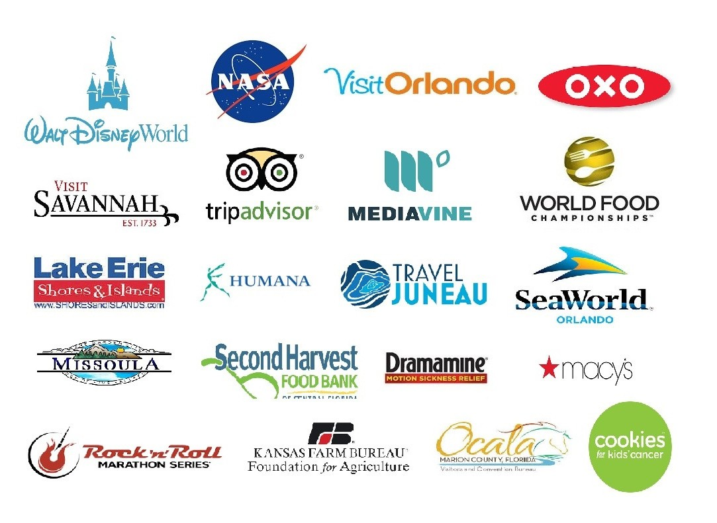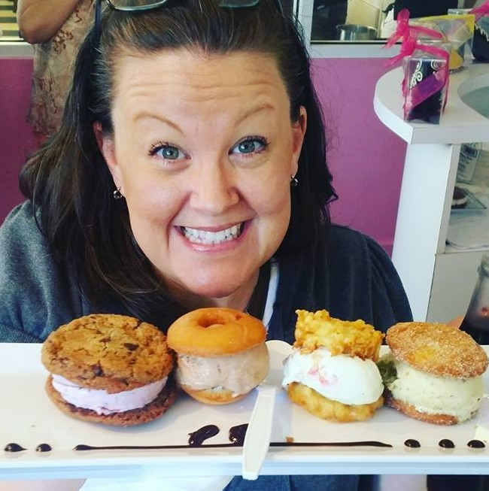

A sampling of brands I have worked with:

C O N T A C T M E A T :

A N N A @ B E A U T Y A N D T H E B E E T S . C O M

